Wendy Shaw

1088 words

**Ottoman Painter's Society**

Established in 1909, the Society of Ottoman Artists (*Osmanlı Ressamlar Cemiyeti*) was the first professional organisation of artists in the Ottoman Empire. Initiated by the artist Mehmet Ruhi Arel and financed by Prince Abdülmecid, it aimed to integrate artistic production and consumption into the general growth of modern civil society envisioned after the Second Constitutional Revolution immediately preceding its institution. Its inclusion of practitioners of traditional book arts in addition to artists working in Western modes of painting and sculpture reflect an integrated vision of modern local cultural production. It disseminated technical and historical information about the arts in the Ottoman and European traditions through its Journal of the Society of Ottoman Artists. After its dissolution in 1919 due to the instability of the Ottoman Empire, similar organisations were established such as the Society of Turkish Painters (*Türk Ressamlar Cemiyeti*, 1921), the Union of Turkish Fine Arts (*Türk Sanayii Nefise Birliği*, 1926), and the *Güzel Sanatlar Birliği*  (1929). Following nearly a century of reforms which implemented modernisation as modelled through Europe, the Second Constitutional Revolution of 1909 realised a long-standing dream among many progressives to establish a constitutional monarchy. It followed the long reign of Sultan Abdülhamid II (r. 1876 – 1909), who had used war with Russia in 1877 to foil the first constitutional revolution, following his ascension to power after a coup against Sultan Abdulaziz the previous year.

Despite great strides in the dissemination of bureaucratic, educational, technological, and urban education, Sultan Abdülhamid advocated social conservatism that emphasised his credentials as Caliph of the Islamic world and protector of Muslims inside and outside of the shrinking Ottoman Empire. Increasingly concerned about the possibilities of an assassination attempt or coup such as that which had initiated his own reign, the ten years preceding his deposition had been fraught with censorship that restricted cultural production. Thus the Second Constitutional Revolution, led by the Committee of Union and Progress, promoting equal citizenship, growth in civil society, and advocating Westernizing cultural values, initially held great promise for many progressive citizens of the Ottoman Empire.

The idea to create a professional forum and legal protection for fine artists began with Mehmed Ruhi (Arel; 1880-1931), a graduate of the Naval Academy, who informally assembled his friends at his home in the Şehzadebaşı district of Istanbul in 1909. Mehmed Sami (Yetik; 1878-1935), Şevket (Dağ; 1876-1948), Hikmet (Onat; 1882-1977), İbrahim (Çallı; 1882-1960), Ali Rıza (1858-1939), Ahmed Ziya, Şerif Abdülkadirzade Hüseyin Haşim, Ahmed İzzet, Mehmed Muazzez, Mahmud and İzzet Mesmur attended these meetings. Some of the initial members were recent graduates of the academy, while others were art teachers. Although the organization was initially founded among friends, it became economically viable only under the patronage of Prince Abdülmecid (1868-1944), who had spent his life before the revolution under luxurious house arrest after the deposition of his father in 1876. More artists joined, including Osman Asaf, Darüsşafakalı Galip, Ömer Adil (1868-1928), Nazmi Ziya (Güran; 1881-1937), Hüseyin Avni, Mehmed Ali, Feyhaman (Duran; 1886-1970), Hasan Vecih (Bereketoğlu; 1895-1971), Namık İsmail (1890-1935), Üsküdarlı Cevat (Göktengiz; 1871-1939), Celal Esad (Arseven; 1876-1971), Mithat Rebii, and the women artists Mihri Rasim/Müşfik (1886-1956) and Müfide Kadri (1890-1912). Artists came from varying educational backgrounds and all forms of art were within the range of interest of the organization, which included a sculptor and a calligrapher. While practitioners of traditional arts were not members of the organization, the *Journal of the Society of Ottoman Artists (Osmanlı Ressamlar Cemiyeti Gazetesi)* included articles on calligraphy and illumination. Although many of its members went to Paris for their education soon after its foundation, they continued to participate in debates about the nature and role of art back home, and also sent letters and sketches from Paris.

The journal published eighteen issues between 1911 and 1914. Its fırst issue expressed four aims: to serve as a forum among artists to discuss the role of art in society; to provide information about the history and techniques of art; to provide monographic information about important Ottoman artists; and to advertise the Society of Ottoman Artists center, which included the first permanent sales-oriented gallery in the empire. Edited by Şerif Abdülkadirzade Hüseyin Haşim, the journal featured articles on art history, the philosophy of art, art technique, and monographs on Turkish and European artists. It also included technical discussions of perspectival construction and of oil paint and color. In contrast to most Western critical discourse, this journal was far more interested in the role of art and the artist in society and in the technical aspects of art than in its communicative function – a mode of sociological rather than analytical treatment or criticism.

An elaborate masthead illustrated the journal’s objectives. The front page of each issue features a complex emblem with two brushes of different shapes tied with a large ribbon hanging through the thumbhole of a palette daubed with paints in front of several tools of the trade – a compass, a tube of paint, and etching tools. This grouping precedes a scene framed by a crescent moon, showing a desk with a portrait bust of Prince Abdülmecid wearing a suit and fez. To the side, a mechanical pencil holder and the end of a laurel branch hold open a scroll bearing the organization’s name. A second laurel branch unites the composition, framing it as a single medallion pierced by a maulstick. Through this emblem, the journal presents itself as an agent of professionalization, promising to give meaning to the technical aspects of art making while promoting an organic and progressive conjunction of Western and Ottoman traditions.

The connection of the paper with the notion of progress implied affiliation with the Committee for Union and Progress. The repeated emphasis on copying from nature in discussions of aesthetics strengthened this association with scientific endeavor. As was the case for public art institutions of the late empire, this private institutionalization of art, while conservative in its artistic approaches, incorporated social utilitarianism and political radicalism.

**References and further reading**:

Başkan, Seyfi. *Osmanlı Ressamlar Cemiyeti.* Ankara: Çardaş Yayınları, 1994.

Renda, Günsel, Turan Erol, Adnan Turani, Kaya Özsezgin, and Mustafa Aslıer. *A History of Turkish Painting.* Seattle, London: Palasar SA in association with University of Washington Press, 1988.

Shaw, Wendy M. K., *Ottoman Painting: Reflections of Western Art in the Ottoman Empire.* London: I. B. Tauris, 2011.

Yağbasan, Eylem. “Ressam Halife Abdülmecid Efendi (1868-1944).” In *Hanedandan Bir Ressam Abdülmecid Efendi*, by ed. Ömer Faruk Şerifoğlu, 23-62. Istanbul: Yapı Kredi Ticaret ve Sanayi A. Ş., 2004.

Zihnioğlu, Yaprak, ed. *Osmanlı Ressamlar Cemiyeti Gazetesi 1911-1914 Güncelleştirilmiş Basım.* Istanbul: Kitap Yayınevi, 2007.

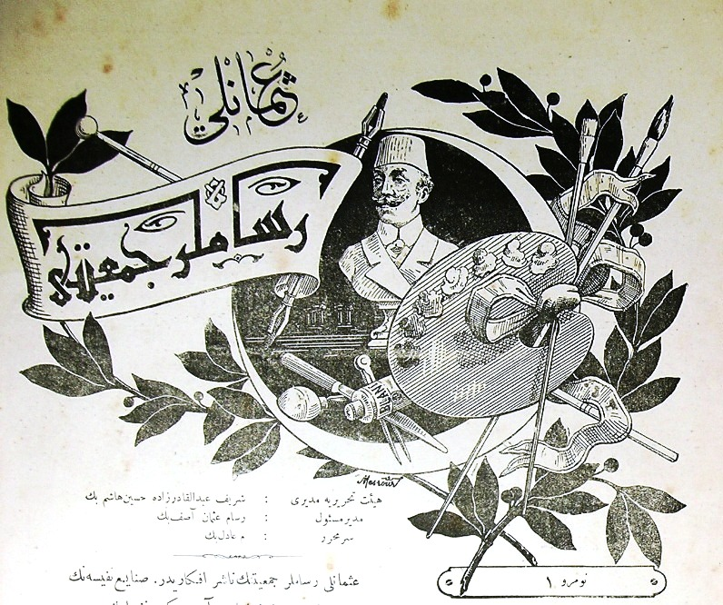

Masthead, Journal of the Society of Ottoman Artists. 1911.

This is not copywrited.